WWD Assignment

Student Name: Deepshikha Wadikar

Student Number: D17128916

Introduction

In this report I have analyzed five data sets to get the idea of the data and how to derive results. I have used R language to explore the data.Various packages and its functions/libraries are used to produce the results and different types of visuals are created for the given tasks wherever required.

TASK 1.1

Quarterly Economic Indicators In this task, firstly the ‘dublin employment trends.txt’ file is imported in R using read.csv function. The graph - ‘Dublin Employment Trends Per Sector: 2006-2016’ is created using ggplot() function which is present ggplot2 library. The graph displays the various trends present in Dublin Employment different Sector.

Line charts displays the trends and are easy to notice the trend in each sector. In the Construction Employment sector it is seen like initially there was little hike then there is a gradual decrease in the employment then again towards the end there is a slight up in the count. In Finance sector there is a constant up and down has been observed throughout the years. IT sector has seen a down trend in 2010 around then after that a continuous increase in growth has been observed. In Retail sector there was an upward trend is observed in the initial years only then afterwards there was downward trend only. There is a huge fall in the Scientific sector during the middle around 2011. Tourism was initially no trending then around 20111-2012 there was a downfall in the trend but again at the end around 2015-16 there was a boom in employment. Lastly in the Transport sector it is initially an upward trend is observed then downward and again followed by an upward trend.
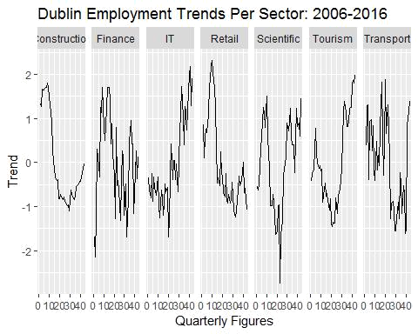

TASK 1.2

In ‘Dublin Property Trends : 2007-2016’ graph a U-shaped graph is observed displaying the property trends for various categories of properties in Dublin. The various categories of properties depicted in the graph are - Apt Rental, House Prices, House Rental and Houses Built. The Apt Rental and house rentals followed the similar trend with few minor differences. Similarly the trends for house built and house prices are following same trend. Initially as per the graph when more houses were getting built then the prices for houses also increased but afterwards when the house construction rate was lowered then the house prices also went down. There is a correlation found in these two categories.
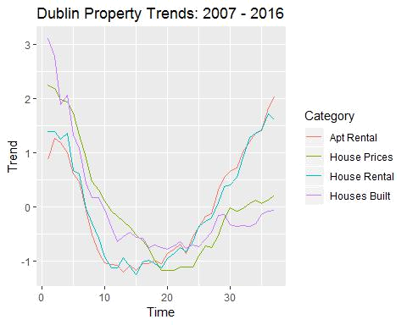

TASK 2

(Real-time) bike Info Real Time Dublin Bike data is imported in R using GET function and an api key.After that the data is stored in a data frame using a simple for loop and rbind function.

TASK 2.1

An analysis has been performed on the Dublin bike data to get the information about different bike stands location. Number of bike stand locations by calculating the number of rows using nrow() function. Then structure of bike data is analyzed. Then maximum number of bikes available, available bike stands and bike stands mean , maximum and minimum values are calculated to know the basic details of bike in Dublin.

The typeof() function is used to determine the type of each column present in Dublin Bike Data.

In Bike Data there are total 13 variables present.These variables are-

- number-> This variable indicates the bike number.It is of ‘integer’ type.

- contract_name -> This variable displays the city name.It is of type ‘integer’.

- name -> This variable gives the name of the street.This is also of type ‘integer’.
- address -> This variable gives the complete address of the street where the Bike is positioned.It is of ‘integer’ type.

- position.lat -> It is of type ‘double’.This variable displays the bike latitude position.

- position.lon -> It is of type ‘double’.This variable displays the bike longitudinal position.

- banking -> It is of ‘logical’ type.

- bonus -> It is of ‘logical’ type.

- bike_stands -> It is of ‘integer’ type.This dislays the bike stand number.

- available_bikes -> It is of ‘integer’ type.This dislays the total number of bikes available in bike stand.

- status -> It is of ‘integer’ type.This dislays the current status of bike stand.

- last_update -> The variable is of type ‘double’.This displays the value when the status is updated.

The bikeData Summary is calculated to display the total number of bike_stands,total available_bike_stands and total available bikes.

Total_Stands = 3654 Total_available_bike_stands = 2371 Total_available_bikes = 1269

TASK 2.2

In this Task three variables - available bike stands, available bikes and Location are mainly focused on to get the available bike and available bike stand details. For this the data is divided into two parts by using subset function as per the location number. Then after that the data is cleaned by keeping only three variables of interest for plotting a comparison graph. The melt function of library reshape2 is used over here to plot a stacked bar graph. For plotting a comparison graph ggplot function is used. The address is kept on x-axis and the count of available bikes and available bike stands are present on the y-axis. This stacked bar chart is really good to get a quick overview to a time pressured individual about the available bikes and available bike stands. It is a good graph to get an idea of availability and also to compare the bike and bike stand availabilities with other locations. For any individual it would be really an easy task to get to know like from which nearby area they can pick a bike and on which available bike stands they can park.

By this user is getting the Bike stands count also for a particular address as Bike Stands count is equal to the addition of variables available bike stands and available bikes.
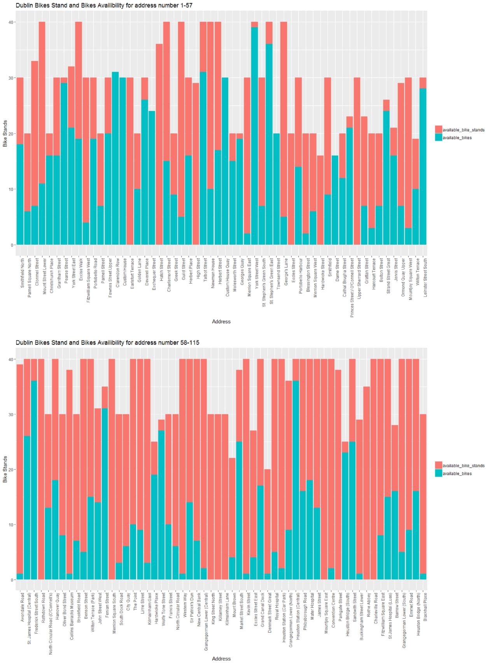

TASK 3

(Scale) Dublin Bus
The Dublin Bus dataset provide the information of all the bus routes in Dublin city, the different trips, the stop details of each route, the stop times etc. After downloading the file the file is unzipped using ‘unzip’ function in the current directory. After that all the files - trips, routes, agency, stops, shapes, calendar, calendar dates, transfers and stop times datasets are imported in R using read.csv function.

TASK 3.1

Now to perform some exploratory data analysis on the datasets the left join is applied. Using dplyr library and left_join function the trips,routes, stop_times and stops datasets are joined together. Then some data cleaning is performed.

Then exploratory analysis is performed and number of stops for each route are calculated. For this sqldf library is used. In this we can write SQL commands within quotes and fetch the required data. Thus by performing this operation we will get the count of stops for each route. After the analysis it has been found that route ‘St. Paul’s Crescent - Irish Life Mall’ route have the maximum 109 number of stops.(Lines 280-285)

Then further analysis is performed to calculate the number of routes passing through each stop. For this only route_id and stop_id columns are selected using select function then the data is converted into a data frame after that the frequency for each route is calculated using table function.One left_join is performed with stops by stop_id. Finally after removing the stops latitude and longitude columns the data frame is now left only with the relevant data. After the analysis of this data it has been found that through the ‘Lowr Leeson Street’ stop maximum number of routes are passing.(Lines 290-305)

TASK 3.2

Let’s consider a person living in Esker Drive area and daily commuting to office at Merrion Square. He is taking bus 25A to travel to and fro from office and home. Firstly we will be needing the route of the bus on map. So for that we need to take the data of route 25A using subset function. After that we will be dividing the data as Outbound and Inbound using subset function. Now after getting the required data using leaflet library. The Dublin map is plotted using the leaflet function and by using the latitude and longitude of the stops the route of the trip ‘Esker Drive - Junction Merrion Square West’ is plotted. Both the Inbound and Outbound stops are displayed on the same map using different colour schemes. After the route plot the Estimated Travel Time of the route is calculated using lubridate library the start time and the end time is fetched then the factor value is converted into hms format and then in numeric. Thus the estimated travel time for route 25A is calculated as 52 hours.(Lines 345-354)

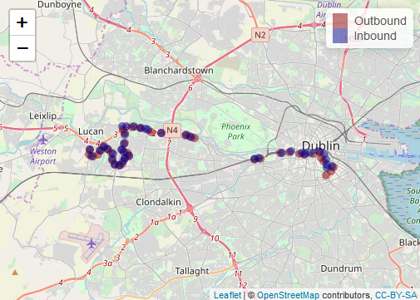
TASK 4.1

(Retail) Footfall

The data for 52 weeks are analyzed from two cameras one from North side and the other from South side. The Henry Street (North Dublin) and Grafton Street (South Dublin) are taken and analyzed for the footfall In and Out for 52 weeks. The data for both the streets are extracted and saved in data frame using rbind function. Using which function the street position is extracted then the extracted data is placed in a data frame. Then the data cleaning is performed. For both the cameras the mean , median ,minimum and maximum footfall count values are calculated using summary function for all the days In and Out for 52 weeks of year 2013.Both the Henry street and Grafton street footfall counts In and Out for Monday are compared using ggplot. Before that comparison the required data is extracted using sqldf function and then the plotting is done using ggplot. The simple bar charts are plotted against Time and Footfall count for 52 weeks using position= dodge. For a particular time two bars were there one for In and the other for Out. Just by looking both the plots it is really easy to compare the footfall count within two cameras as well as in the single plot also to compare the In and Out counts.
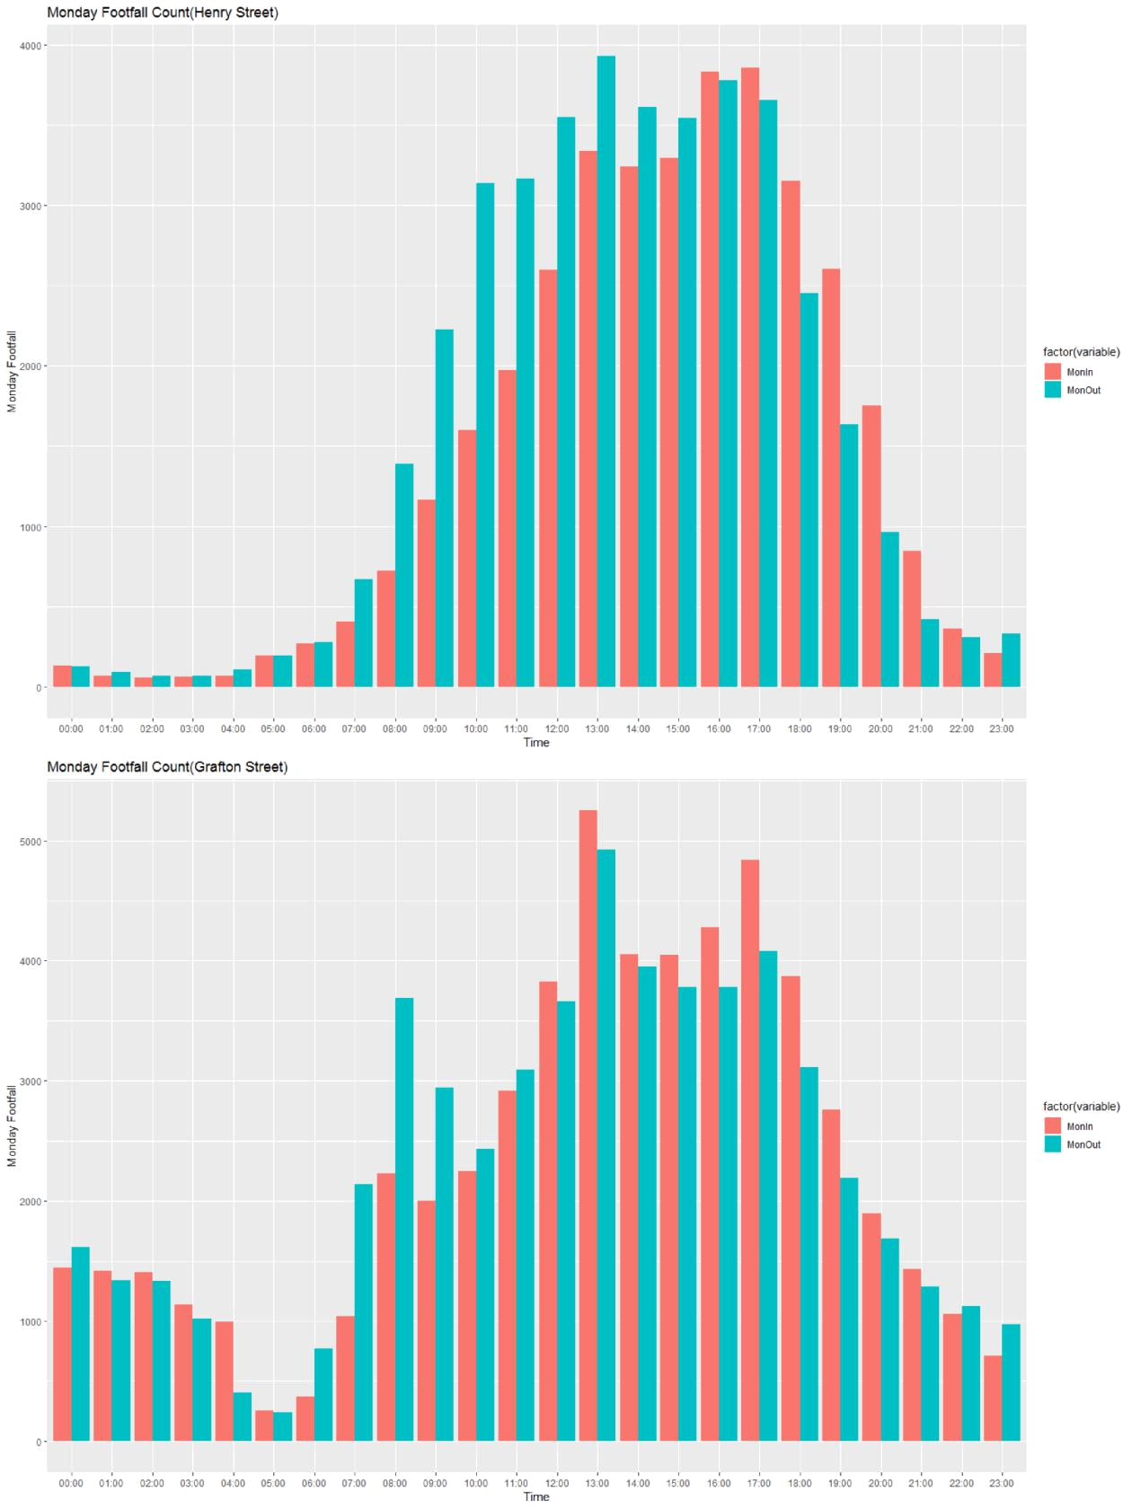
TASK 4.2

Importing York Footfall

The footfall for York city is loaded in the R environment. Using read.csv the data is imported into R. The footfall for year 2013 is extracted using subset function and str_detect function of stringr library. In order to compare the York footfall data with Dublin footfall data the Parliament Street is chosen from York and Grafton street from Dublin. Here a plot is created between the York (Parliament Street M&S) and Dublin (Grafton Street M&S) cameras only for Sunday and In count. The column names for York data are renamed so that it would be easy to understand and analyze the data. Then footfall for Week 8 is selected for both the cities. A simple line graph is plotted for the comparison where x-axis denotes the Time and y-axis denotes the footfall count. By looking into the graph one can easily find out that the footfall count for Dublin city is far more than the footfall count of York city. The footfall count was maximum in time duration 4:00pm to 8:00 pm for Dublin city whereas for York city the maximum footfall count was observed in 1:00pm to 3:00pm.
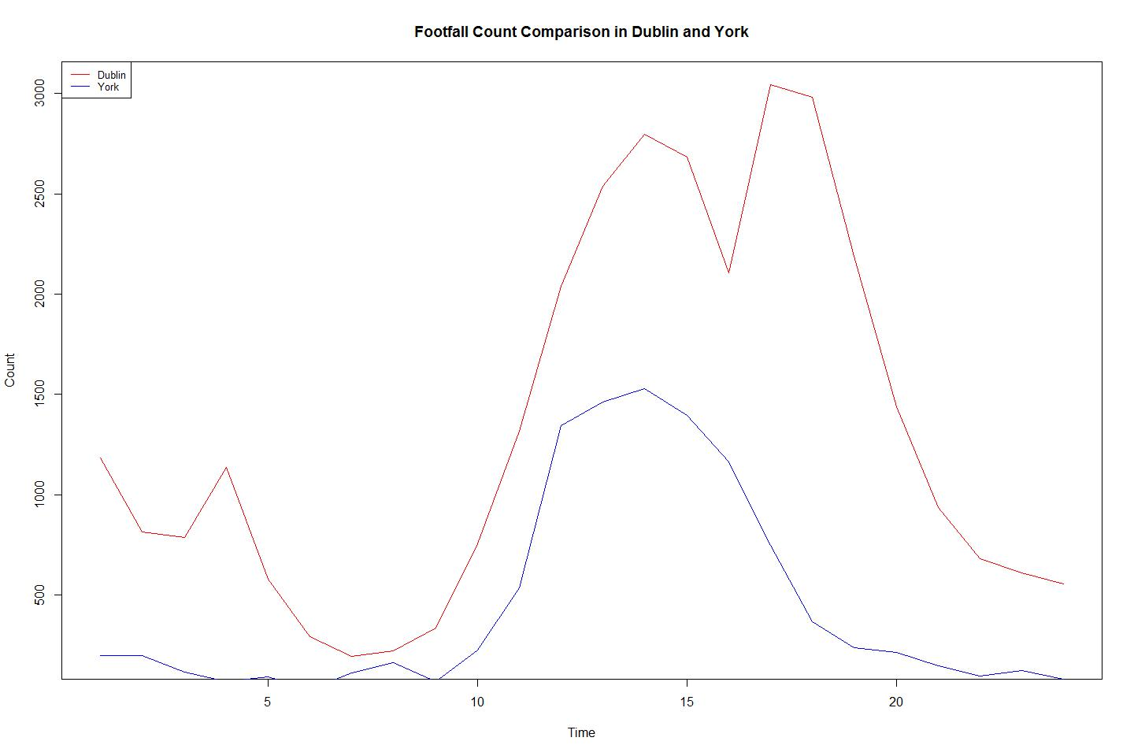

TASK 5.1

The history_database file is generated by RStudio which comprises of various types of command details which a user has executed till now and the time in milliseconds. The history_database file is imported in R using read.csv function. The column names are changed and data is cleaned. Then the number of rows are counted using nrow() function
to know the count of commands used till today. Then the frequency of each command is found using table function to know the frequency. Then using for loop and str_detect function the exact count of few common functions which we frequently use are selected and exact count is calculated. The count is calculated for functions like -read, ggplot, stringr, library, data.frames and a new data frame is created and finally using a ggplot the graph is plotted between the Commands and their respective counts.
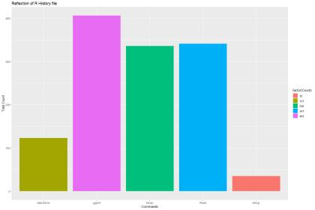

TASK 5.2

The Working with data assignment was really a good assignment to work to learn new things in R. I learnt a lot about different libraries like leaflet, reshape2, sqldf and different concepts such as reading an ods file and to fetch the data using melt function .Also learnt about the R Markdown.All tasks were quite challenging except first task. While working on this assignment I had mixed feelings .After doing the first task I felt so happy but then as I have gone through the other tasks and went ahead my happiness level decreased as I started getting errors and my happiness turned into frustration. Then I came across the reshape2 ,sqldf and leaflet libraries which I implemented and I started getting the desired outputs. Due to this assignment I have really explored a lot and learnt a lot. I enjoyed a lot by doing this assignment as the tasks were quite challenging and interesting to solve and get upto the desired output.

REFERENCES:
Grolemund,G., Wickham, H.(2016). R for Data Science.O’Reilly Media,Inc,USA.

